# Linux – Eclipse IDE Installation

There is more than one way to install the Eclipse IDE in Linux. Installing Eclipse installer from eclipse.org is the simplest way. Start by extracting the installation archive and executing the installer file. On executing the eclipse-inst application file, the following screen should appear.

Figure 3: Selecting the Eclipse IDE for Embedded C/C++ developers

Click on the Eclipse IDE for Embedded C/C++ developers. This will redirect to the installation window shown in Figure 4. Java JDK path of the user’s machine is taken as default as Eclipse uses externally installed JDKs to run itself. Select the installation folder for Eclipse and click Install.

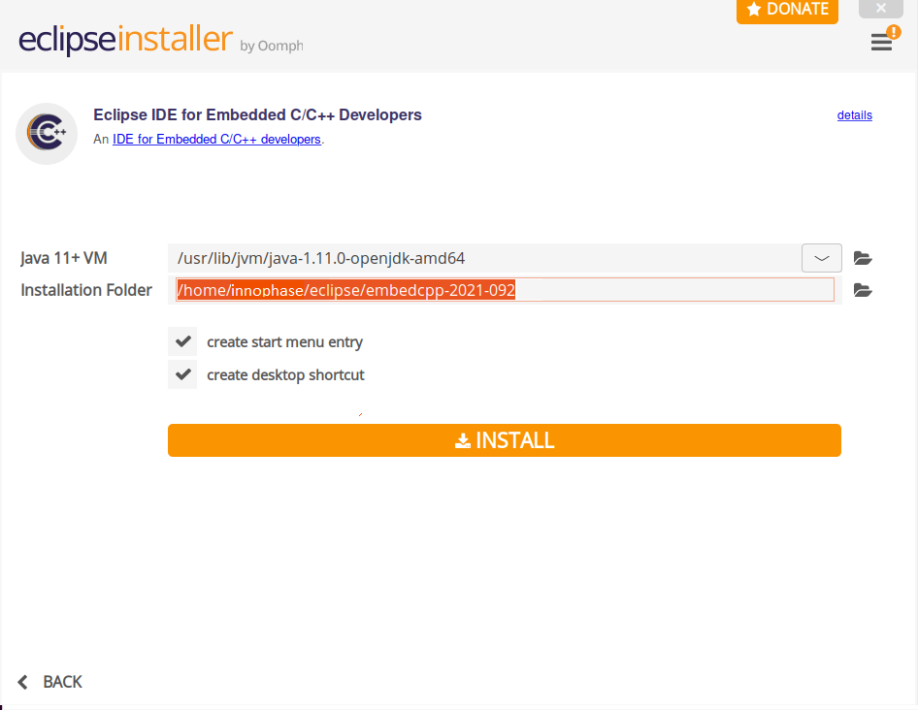

Figure 4: Eclipse IDE for Embedded C/C++ developers’ installation window

Accept the Eclipse Foundation Software User Agreement shown in Figure 5.

Figure 5: Eclipse IDE for Embedded C/C++ developers’ Eclipse User Agreement

After completing installation, Eclipse installer prompts for permission to launch. Click on LAUNCH.

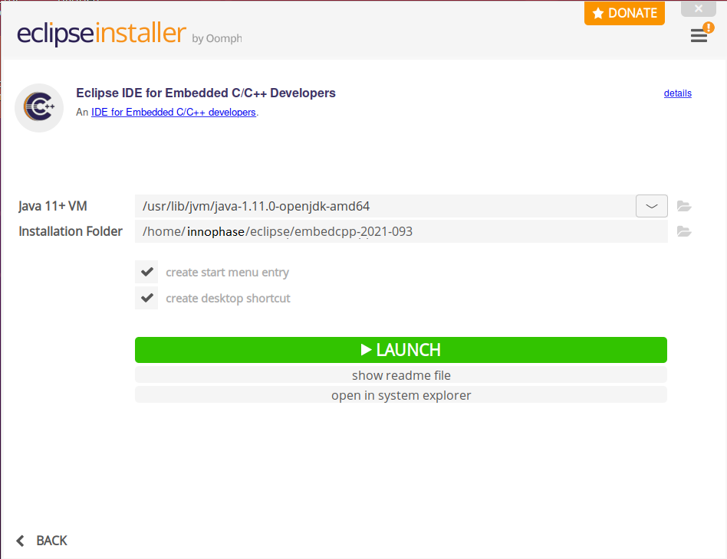

Figure 6: Eclipse IDE for Embedded C/C++ developers launch window